Video of Game Demo

Game: Smartboard Game “Library Vocab Challenge”
Objective: To learn library media terminology, learning to manipulate Smartboard media at the board, as well as working cooperatively as a team.
There are 3 parts to this game, which can be played in succession or can be used as a quicker activity by doing only 1 section at a time as an activity. In teams of 2-3, students will be given 1 minute for the first section of the game, sorting. Students will sort library terminology. The same team will go to the next game, which is unscrambling anagrams using additional and same vocabulary terms. The page is timed for one minute, therefore if they run out of time, they simply get the points collected from the first game, plus points so far, from the anagram game and they sit down. If they complete the anagram without running out of time, they go on to the next and final game, which is a memory game with a one minute timer.

Playing this compilation of three games will have the student engage with the technology of the board by using their hand to manipulate the on-screen graphic game. Instead of just being the receiver of information viewed, hand-eye coordination skills using the interactive touch feature of the board are reinforced while they are learning vocabulary relative to library literacy, and working cooperatively with a partner(s).
As students progress and successfully complete a level, new words will be added, but timer will remain the same.
Core mechanics will be the ability to work collaboratively with a partner(s) while making quick decisions as to where the words need to be moved. They will take turns being the hands on person touching and dragging words into columns. They will be learning new vocabulary and enforcing knowledge of terminology for the library media center. New topics will be added as headings to include technology related terms such as software versus hardware, web 2.0 terms, etc. Throughout the readings, games are referred to as constructivist learning; students making meaning as they go. The first game affords students the ability to classify information and scaffold terms they are not familiar with off of words they already know. Some of the words are repeated in the other games, so repetition offers practice in recall. In the readings, games are also referred to as a designed experience. This group of games offers that experience in that very specific terminology is used and altered by the teacher as he/she edits or changes the game.
Students can reach and touch the “check” button on the board as they sort and organize to see if they are on the right track.

Game 1 of 3 - Sorting
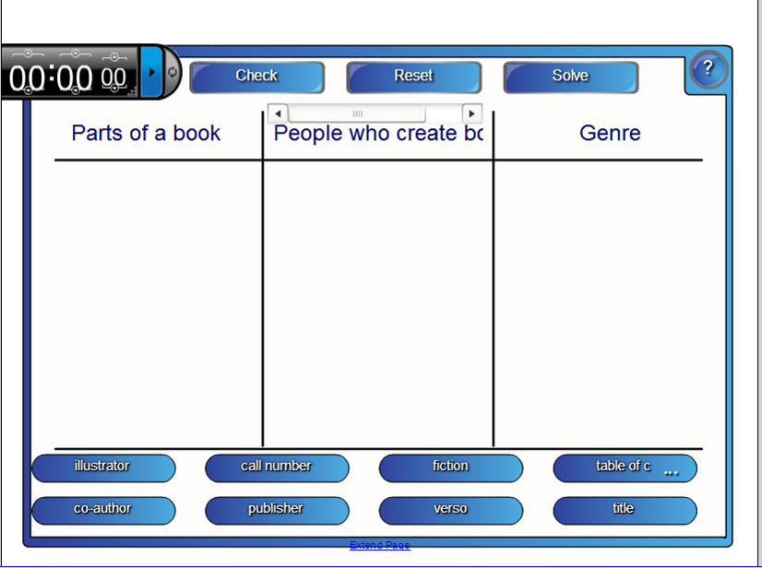
Game begins when teacher rolls a die to select the first team to go. There can also be a die on the Smartboard that gets “rolled” as another option. Teacher sets the timer for 1 minute on the upper left hand corner. First team approaches board, clicks the play button on the timer and begin quickly taking turns to manipulate with hand or fingers, which category each of the words belong in. When they have sorted all of the words, they can click the CHECK button on the top of the screen to check answers. If students complete this level CORRECTLY, at or before the timer is up, they will click the arrow and move to the next game, and the class score keeper will write their score of 16 points on a chart. If they have any incorrect answers, their score is only for the number of correct answers (ie 8 correct, 8 points), but they sit down and the next team in numerical order takes their turn. If team number five, for example was the first to go, then team six will go next.
Game 2 – Anagram
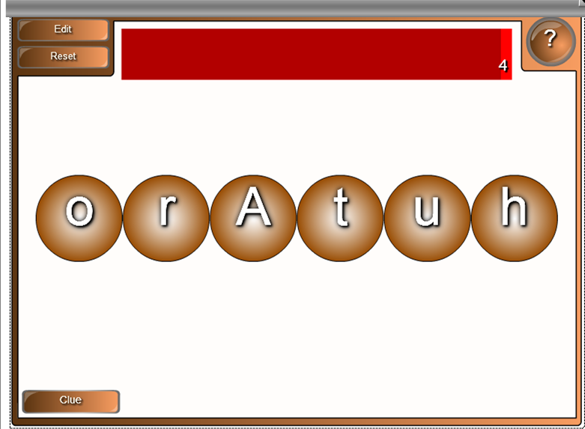
If the team has successfully completed the sorting, they continue to the anagram, which has a built in timer across the top of the screen. Students will work to complete unscrambling the word before the timer goes off. If they do not finish in time, they sit down, no points collected. If they complete unscrambling the first word, they will receive 10 points, and continue on with a new word until they miss. The timer will get faster, controlled by the teacher, with each word.

3 – Memory
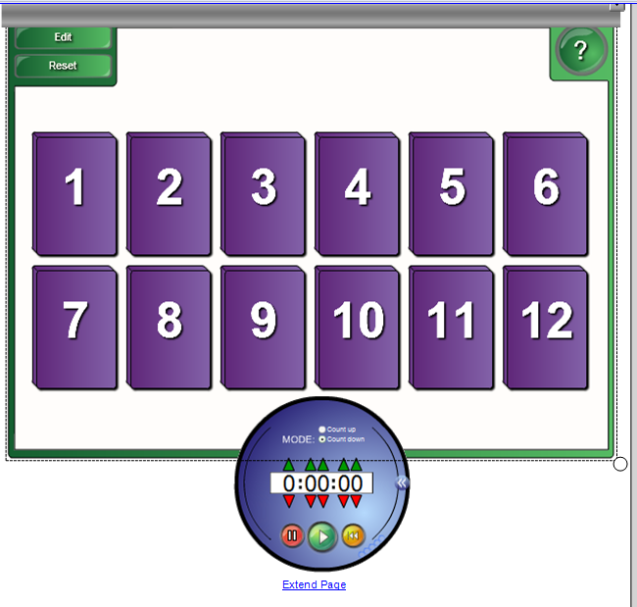
The memory game, which is the third slide of the Smart NOTEBOOK file, is the final game in the series, for those who were successful at completing games 1 and 2. Students on the team will take turns flipping over cards on the board to reveal a word, then try to find its match. It is timed, and students have 1 minute to complete, or they sit down. If they complete this game, 10 points is added to their score.
WINNING – Team with the highest score wins. The number of rounds is determined by the teacher. Other additional ideas would be to give students at their seats, the paper version of the matching/memory game and they can practice at their seats while the other teams take their turn.
Prizes can be awarded such as bookmarks, pencils, free pass to pick out an extra library book, etc.

